Citation: Dahal, M.S., J.Q. Wu, J. Boll, R.P., Ewing, and A. Fowler. 2022. Spatial and agronomic assessment of water erosion on inland Pacific Northwest cereal grain cropland. Journal of Soil and Water Conservation 77(4):347-364. https://doi.org/10.2489/jswc.2022.00091.

Supplementary Materials

Spatial and Agronomic Assessment of Water Erosion on Inland Pacific Northwest Cereal Grain Cropland

Item | Page
S1. Soil Files (Whitman County) | 2
S2. Calculated Hydraulic Conductivity | 4
S3. Management Information | 6
S4. Projected 30-Yr Tillage Proportion | 11
S5. Erosion Maps | 17
S6. Temporal Variation Of Erosion Rates | 23

S1. Soil Files (Whitman County)
Table S1. Deep Soil (Palouse Silt Loam).
Description | Value
Number of layers | 3
Albedo | 0.16
Initial saturation | 0.4
Interill erodibility (kg*s m⁻⁴) | 1E+07
Rill erodibility (s m⁻¹) | 0.018
Critical shear (pa) | 0.35
Surface hydraulic conductivity (mm hr⁻¹) | 1.91
Bedrock depth (mm) | 10000
Restrictive layer Hyd. Cond. (mm hr⁻¹) | 0.01
 | Soil Depth (mm)
 | 0 to 200 | 200 to 600 | 600 to 1800
Bulk density (gm cc⁻¹) | 1.2 | 1.33 | 1.33
Layer Hyd. Cond. (mm hr⁻¹) | 1.91 | 1.4 | 1.4
Anisotropy ratio | 1 | 1 | 5
Field capacity (m m⁻¹) | 0.286 | 0.292 | 0.292
Wilting point (m m⁻¹) | 0.134 | 0.142 | 0.142
Sand (%) | 11.3 | 9.1 | 9.1
Clay (%) | 21 | 25 | 25
Organic (%) | 3 | 0.75 | 0.75
CEC (meq/100 g) | 15 | 20 | 20
Rock (%) | 0 | 0 | 0

Table S2. Moderate Soil (Anders-Kuhl Complex).
Description | Value
Number of layers | 3
Albedo | 0.16
Initial saturation | 0.3
Interill erodibility (kg*s m⁻⁴) | 9221160
Rill erodibility (s m⁻¹) | 0.0148
Critical shear (pa) | 0.30
Surface hydraulic conductivity (mm hr⁻¹) | 7.18
Bedrock depth (mm) | 10000
Restrictive layer hydraulic conductivity (mm hr⁻¹) | 0.01
 | Soil Depth (mm)
 | 0 to 200 | 200 to 600 | 600 to 871
Bulk density (gm cc⁻¹) | 1.25 | 1.35 | 1.4
Layer Hyd. Cond. (mm hr⁻¹) | 7.18 | 8.78 | 18.2
Anisotropy ratio | 1 | 1 | 5
Field capacity (m m⁻¹) | 0.264 | 0.29 | 0.242
Wilting point (m m⁻¹) | 0.094 | 0.1 | 0.114
Sand (%) | 30.4 | 30.4 | 66.8
Clay (%) | 14 | 14 | 7
Organic (%) | 1.5 | 0.75 | 0.75
CEC (meq/100 g) | 5 | 3 | 11.3
Rock (%) | 12.5 | 32.5 | 55.5

Table S3. Shallow Soil (Kuhl-Alpowa Complex).
Description | Value
Number of layers | 3
Albedo | 0.16
Initial saturation | 0.3
Interill erodibility (kg*s m⁻⁴) | 9259580
Rill erodibility (s m⁻¹) | 0.0148
Critical shear (pa) | 0.29
Surface hydraulic conductivity (mm hr⁻¹) | 28.1
Bedrock depth (mm) | 10000
Restrictive layer hydraulic conductivity (mm hr⁻¹) | 0.01
 | Soil Depth (mm)
 | 0 to 200 | 200 to 300 | 300 to 437
Bulk density (gm/cc) | 1.25 | 1.33 | 1.4
Layer Hyd. Cond. (mm hr⁻¹) | 5.59 | 5.25 | 18.2
Anisotropy ratio | 1 | 1 | 5
Field capacity (m m⁻¹) | 0.295 | 0.292 | 0.242
Wilting point (m m⁻¹) | 0.1 | 0.1 | 0.114
Sand (%) | 30.9 | 30.4 | 66.8
Clay (%) | 12.5 | 14 | 7
Organic (%) | 1.5 | 0.5 | 0.5
CEC (meq/100 g) | 12.5 | 15 | 11.3
Rock (%) | 36.2 | 36.2 | 55.5

S2. Calculated Hydraulic Conductivity
Table S4. Baseline Hydraulic Conductivity by Soil Depth
County |  | Deep | Moderate | Shallow
 |  | (mm hr⁻¹)
Adams | Layer 1 | 4.45 | 4.45 | 18.2
 | Layer 2 | 4.45 | 4.45 | 18.2
 | Layer 3 | 4.45 | 18.2 | 18.2
Asotin | Layer 1 | 5.25 | 2.42 | 4.08
 | Layer 2 | 5.25 | 2.42 | 4.08
 | Layer 3 | 9.84 | 2.42 | 4.08
Benton | Layer 1 | 4.45 | 4.45 | 3.43
 | Layer 2 | 4.45 | 4.45 | 3.43
 | Layer 3 | 4.45 | 18.2 | 3.43
Columbia | Layer 1 | 1.89 | 7.3 | 5.4
 | Layer 2 | 1.44 | 6.21 | 3.67
 | Layer 3 | 1.89 | 18.2 | 18.2
Douglas | Layer 1 | 3.84 | 20.7 | 20.7
 | Layer 2 | 3.78 | 20.9 | 20.2
 | Layer 3 | 2.59 | 19.2 | 20
Franklin | Layer 1 | 4.45 | 11.2 | 6.2
 | Layer 2 | 4.45 | 7.79 | 6.2
 | Layer 3 | 4.45 | 43 | 18.2
Garfield | Layer 1 | 1.89 | 4.19 | 5.4
 | Layer 2 | 1.44 | 4.28 | 2.73
 | Layer 3 | 1.89 | 18.2 | 18.2
Grant | Layer 1 | 4.45 | 4.14 | 3.84
 | Layer 2 | 4.23 | 4.24 | 3.78
 | Layer 3 | 4.04 | 4.24 | 2.59
Lincoln | Layer 1 | 2.49 | 4.14 | 7.18
 | Layer 2 | 2.04 | 4.24 | 8.78
 | Layer 3 | 2.04 | 4.24 | 18.2
Spokane | Layer 1 | 1.59 | 18.2 | 9.54
 | Layer 2 | 1.23 | 2.17 | 9.65
 | Layer 3 | 1.05 | 18.2 | 18.2
Walla Walla | Layer 1 | 4.45 | 6.24 | 6.24
 | Layer 2 | 4.45 | 2.72 | 2.72
 | Layer 3 | 4.45 | 18.2 | 18.2
Whitman | Layer 1 | 1.91 | 7.18 | 5.59
 | Layer 2 | 1.4 | 8.78 | 5.25
 | Layer 3 | 1.4 | 18.2 | 18.2

S3. Management Information

Rotations

1. WW-B-P: Winter Wheat-Barley-Pea
2. WW-B-F: Winter Wheat-Barley-Fallow
3. WW-F: Winter Wheat-Fallow

S3.1 WW-B-P
Table S5. Intense tillage.
Dates | Operation | Details | Remarks
1/1/01 | Initial Conditions | After winter wheat seeding previous fall
8/25/01 | Harvest - Annual | Wheat; Winter - Washington
10/15/01 | Tillage | Tandem disk harrow | Depth: 4.00 in; Type: Sec
4/15/02 | Tillage | Chisel plow, twisted points or shovels | Depth: 8.00 in; Type: Pri
4/16/02 | Tillage | Harrow-spike tooth | Depth: 3.00 in; Type: Sec
4/17/02 | Tillage | Harrow-spike tooth in opposite direction | Depth: 3.00 in; Type: Sec
4/18/02 | Tillage | Drill, single disk opener (conventional) | Depth: 1.00 in; Type: Sec
4/18/02 | Plant - Annual | Barley | Row Width: 7.00 in
8/15/02 | Harvest - Annual | Barley
10/15/02 | Tillage | Tandem disk harrow | Depth: 4.00 in; Type: Sec
4/15/03 | Tillage | Chisel plow, twisted points or shovels | Depth: 8.00 in; Type: Pri
4/24/03 | Tillage | Harrow-spike tooth | Depth: 3.00 in; Type: Sec
4/25/03 | Tillage | Harrow-spike tooth in opposite direction | Depth: 3.00 in; Type: Sec
4/26/03 | Tillage | Field cultivation for herbicide incorporation | Depth: 3.00 in; Type: Sec
5/1/03 | Tillage | Drill, single disk opener (conventional) | Depth: 2.00 in; Type: Sec
5/1/03 | Plant - Annual | Peas | Row Width: 7.00 in
8/25/03 | Harvest - Annual | Peas
9/3/03 | Tillage | Plow, Moldboard with uphill furrow (Pacific NW only) | Depth: 8.00 in; Type: Pri
9/19/03 | Tillage | Tandem disk harrow | Depth: 4.00 in; Type: Sec
9/20/03 | Tillage | Harrow-spike tooth | Depth: 3.00 in; Type: Sec
9/21/03 | Tillage | Harrow-spike tooth in opposite direction | Depth: 3.00 in; Type: Sec
9/28/03 | Tillage | Anhydrous applicator | Depth: 8.00 in; Type: Sec
10/10/03 | Tillage | Drill with double disk opener | Depth: 1.00 in; Type: Sec
10/10/03 | Plant - Annual | Wheat; Winter - Washington | Row Width: 7.00 in

Table S6. Reduced tillage.
Dates | Operation | Details | Remarks
1/1/01 | Initial Conditions | After winter wheat seeding previous fall
8/25/01 | Harvest - Annual | Wheat; Winter - Washington
4/16/02 | Tillage | Chisel plow, straight with spike pts | Depth: 6.00 in; Type: Sec
4/17/02 | Tillage | Harrow-spike tooth | Depth: 3.00 in; Type: Sec
4/18/02 | Tillage | Drill, single disk opener (conventional) | Depth: 1.00 in; Type: Sec
4/18/02 | Plant - Annual | Barley | Row Width: 7.00 in
8/15/02 | Harvest - Annual | Barley
4/14/03 | Tillage | Chisel plow, straight with spike pts | Depth: 6.00 in; Type: Sec
4/15/03 | Tillage | Harrow-spike tooth | Depth: 3.00 in; Type: Sec
4/26/03 | Tillage | Field cultivation for herbicide incorporation | Depth: 3.00 in; Type: Sec
5/1/03 | Tillage | Drill, single disk opener (conventional) | Depth: 2.00 in; Type: Sec
5/1/03 | Plant - Annual | Peas | Row Width: 7.00 in
8/25/03 | Harvest - Annual | Peas
9/20/03 | Tillage | Chisel plow, straight with spike pts | Depth: 6.00 in; Type: Sec
9/20/03 | Tillage | Harrow-spike tooth | Depth: 3.00 in; Type: Sec
9/28/03 | Tillage | Anhydrous applicator | Depth: 8.00 in; Type: Sec
10/10/03 | Tillage | Drill with double disk opener | Depth: 1.00 in; Type: Sec
10/10/03 | Plant - Annual | Wheat; Winter - Washington | Row Width: 7.00 in

Table S7. No-till.
Dates | Operation | Details | Remarks
1/1/01 | Initial Conditions | After winter wheat seeding previous fall
8/25/01 | Harvest - Annual | Wheat; Winter - Washington
4/18/02 | Tillage | Drill, no-till in flat residues-ripple or bubble coult | Depth: 1.00 in; Type: Sec
4/18/02 | Plant - Annual | Barley | Row Width: 7.00 in
8/15/02 | Harvest - Annual | Barley
4/26/03 | Herbicide application
5/1/03 | Tillage | Drill, no-till in standing stubble-smooth coulters | Depth: 2 in; Type: Sec
5/1/03 | Plant - Annual | Peas | Row Width: 7.00 in
8/25/03 | Harvest - Annual | Peas
9/28/03 | Tillage | Anhydrous applicator | Depth: 4.00 in; Type: Sec
10/10/03 | Tillage | Drill, no-till in standing stubble-fluted coulters | Depth: 1 in; Type: Sec
10/10/03 | Plant - Annual | Wheat; Winter - Washington | Row Width: 7.00 in

S3.2 WW-B-F
Table S8. Intense tillage.
Dates | Operation | Details | Remarks
1/1/01 | Initial Conditions | After winter wheat seeding previous fall
8/25/01 | Harvest - Annual | Wheat; Winter - Washington
10/15/01 | Tillage | Tandem disk harrow | Depth: 4.00 in; Type: Sec
4/15/02 | Tillage | Chisel plow, twisted points or shovels | Depth: 8.00 in; Type: Pri
4/16/02 | Tillage | Harrow-spike tooth | Depth: 3.00 in; Type: Sec
4/17/02 | Tillage | Harrow-spike tooth in opposite direction | Depth: 3.00 in; Type: Sec
4/18/02 | Tillage | Drill, single disk opener (conventional) | Depth: 1.00 in; Type: Sec
4/18/02 | Plant - Annual | Barley | Row Width: 12.00 in
8/15/02 | Harvest - Annual | Barley
10/15/02 | Tillage | Disk, offset-heavy plowing>10" spacing | Depth: 4.00 in; Type: Sec
4/15/03 | Tillage | Rodweeder, plain rotary rod | Depth: 2 in; Type: Sec
5/15/03 | Tillage | Rodweeder, plain rotary rod | Depth: 2 in; Type: Sec
8/1/03 | Tillage | Rodweeder, plain rotary rod | Depth: 2 in; Type: Sec
9/3/03 | Tillage | Plow, Moldboard with uphill furrow (Pacific NW only) | Depth: 8.00 in; Type: Pri
9/15/03 | Tillage | Tandem disk harrow | Depth: 4.00 in; Type: Sec
9/23/03 | Tillage | Harrow-spike tooth | Depth: 3.00 in; Type: Sec
9/24/03 | Tillage | Harrow-spike tooth in opposite direction | Depth: 3.00 in; Type: Sec
9/28/03 | Tillage | Anhydrous applicator | Depth: 8.00 in; Type: Sec
10/10/03 | Tillage | Drill with double disk opener | Depth: 1.00 in; Type: Sec
10/10/03 | Plant - Annual | Wheat; Winter - Washington | Row Width: 12.00 in

Table S9. Reduced tillage.
Dates | Operation | Details | Remarks
1/1/01 | Initial Conditions | After winter wheat seeding previous fall
8/25/01 | Harvest - Annual | Wheat; Winter - Washington
4/15/02 | Tillage | Chisel plow, straight with spike pts | Depth: 6.00 in; Type: Pri
4/17/02 | Tillage | Harrow-spike tooth | Depth: 3.00 in; Type: Sec
4/18/02 | Tillage | Drill, single disk opener (conventional) | Depth: 1.00 in; Type: Sec
4/18/02 | Plant - Annual | Barley | Row Width: 12.00 in
8/15/02 | Harvest - Annual | Barley
5/15/03 | Tillage | Rodweeder, plain rotary rod | Depth: 2 in; Type: Sec
8/25/03 | Tillage | Chisel plow, straight with spike pts | Depth: 6.00 in; Type: Pri
9/20/03 | Tillage | Harrow-spike tooth | Depth: 3.00 in; Type: Sec
9/28/03 | Tillage | Anhydrous applicator | Depth: 8.00 in; Type: Sec
10/10/03 | Tillage | Drill with double disk opener | Depth: 1.00 in; Type: Sec
10/10/03 | Plant - Annual | Wheat; Winter - Washington | Row Width: 12.00 in

Table S10. No-till.
Dates | Operation | Details | Remarks
1/1/01 | Initial Conditions | After winter wheat seeding previous fall
8/25/01 | Harvest - Annual | Wheat; Winter - Washington
4/18/02 | Tillage | Drill, no-till in flat residues-ripple or bubble coulters | Depth: 1.00 in; Type: Sec
4/18/02 | Plant - Annual | Barley | Row Width: 12.00 in
8/15/02 | Harvest - Annual | Barley
9/28/03 | Tillage | Anhydrous applicator | Depth: 4.00 in; Type: Sec
10/10/03 | Tillage | Drill, no-till in standing stubble-fluted coulters | Depth: 1.00 in; Type: Sec

S3.3. WW-F
Table S11. Intense tillage.
Dates | Operation | Details | Remarks
1/1/01 | Initial Conditions | After winter wheat seeding previous fall
7/25/01 | Harvest - Annual | Wheat; Winter - Washington
8/20/01 | Tillage | Disk, offset-heavy plowing>10" spacing | Depth: 8.00 in; Type: Sec
4/1/02 | Tillage | Rodweeder, plain rotary rod | Depth: 2 in; Type: Sec
5/15/02 | Tillage | Rodweeder, plain rotary rod | Depth: 2 in; Type: Sec
8/1/02 | Tillage | Rodweeder, plain rotary rod | Depth: 2 in; Type: Sec
8/25/02 | Tillage | Plow, Moldboard with uphill furrow (Pacific NW only) | Depth: 8.00 in; Type: Pri
9/6/02 | Tillage | Tandem disk harrow | Depth: 4.00 in; Type: Sec
9/7/02 | Tillage | Harrow-spiketooth | Depth: 3.00 in; Type: Sec
9/8/02 | Tillage | Harrow-spike tooth in opposite direction | Depth: 3.00 in; Type: Sec
9/9/02 | Tillage | Anhydrous applicator | Depth: 8.00 in; Type: Sec
9/14/02 | Tillage | Drill with double disk opener | Depth: 1.00 in; Type: Sec
9/14/02 | Plant - Annual | Wheat; Winter - Washington | Row Width: 15.00 in

Table S12. Reduced tillage.
Dates | Operation | Details | Remarks
1/1/01 | Initial Conditions | After winter wheat seeding previous fall
7/25/01 | Harvest - Annual | Wheat; Winter - Washington
5/15/02 | Tillage | Rodweeder, plain rotary rod | Depth:2 in; Type: Sec
8/26/02 | Tillage | Chisel plow, straight with spike pts | Depth: 6.00 in; Type: Pri
9/6/02 | Tillage | Harrow-spike tooth | Depth: 3.00 in; Type: Sec
9/9/02 | Tillage | Anhydrous applicator | Depth: 8.00 in; Type: Sec
9/14/02 | Tillage | Drill with double disk opener | Depth: 1.00 in; Type: Sec
9/14/02 | Plant - Annual | Wheat; Winter - Washington | Row Width: 15.00 in

Table S13. No-till.
Dates | Operation | Details | Remarks
1/1/01 | Initial Conditions | After winter wheat seeding previous fall
7/25/01 | Harvest - Annual | Wheat; Winter - Washington
9/9/02 | Tillage | Anhydrous applicator | Depth: 4.00 in; Type: Sec
9/14/02 | Tillage | Drill, no-till in standing stubble-fluted coulters | Depth: 1.00 in; Type: Sec
9/14/02 | Plant - Annual | Wheat; Winter - Washington | Row Width: 15.00 in

S4. Projected 30-yr Tillage Proportion

Years with * are the recorded years while the remaining years are estimated.

Table S14. Annual percentages of intense, reduced, and no-till tillage.
 | Adams County |  |  | Asotin County
Year | Intense | Reduced | No-till | Intense | Reduced | No-till
2018 | 41.2 | 54.0 | 4.8 | 3.2 | 21.6 | 75.3
2017* | 42.3 | 53.4 | 4.3 | 5.1 | 19.7 | 75.2
2016 | 43.3 | 52.8 | 3.8 | 7.0 | 17.8 | 75.2
2015 | 44.4 | 52.2 | 3.4 | 8.8 | 16.0 | 75.2
2014 | 45.5 | 51.6 | 2.9 | 10.7 | 14.1 | 75.2
2013 | 46.6 | 51.0 | 2.4 | 12.6 | 12.3 | 75.1
2012* | 47.6 | 50.4 | 2.0 | 14.5 | 10.4 | 75.1
2011 | 48.7 | 49.8 | 1.5 | 16.4 | 8.6 | 75.1
2010 | 49.8 | 49.2 | 1.0 | 18.2 | 6.7 | 75.1
2009 | 50.9 | 48.6 | 0.6 | 20.1 | 4.8 | 75.0
2008 | 51.9 | 48.0 | 0.1 | 22.0 | 3.0 | 75.0
2007 | 52.6 | 47.4 | 0.0 | 23.9 | 1.1 | 75.0
2006 | 53.2 | 46.8 | 0.0 | 25.0 | 0.0 | 75.0
2005 | 53.8 | 46.2 | 0.0 | 25.1 | 0.0 | 74.9
2004 | 54.4 | 45.6 | 0.0 | 25.1 | 0.0 | 74.9
2003 | 55.0 | 45.0 | 0.0 | 25.1 | 0.0 | 74.9
2002 | 55.7 | 44.4 | 0.0 | 25.1 | 0.0 | 74.9
2001 | 56.3 | 43.7 | 0.0 | 25.2 | 0.0 | 74.8
2000 | 56.9 | 43.1 | 0.0 | 25.2 | 0.0 | 74.8
1999 | 57.5 | 42.5 | 0.0 | 25.2 | 0.0 | 74.8
1998 | 58.1 | 41.9 | 0.0 | 25.2 | 0.0 | 74.8
1997 | 58.7 | 41.3 | 0.0 | 25.3 | 0.0 | 74.8
1996 | 59.3 | 40.7 | 0.0 | 25.3 | 0.0 | 74.7
1995 | 59.9 | 40.1 | 0.0 | 25.3 | 0.0 | 74.7
1994 | 60.5 | 39.5 | 0.0 | 25.3 | 0.0 | 74.7
1993 | 61.1 | 38.9 | 0.0 | 25.3 | 0.0 | 74.7
1992 | 61.7 | 38.3 | 0.0 | 25.4 | 0.0 | 74.6
1991 | 62.3 | 37.7 | 0.0 | 25.4 | 0.0 | 74.6
1990 | 62.9 | 37.1 | 0.0 | 25.4 | 0.0 | 74.6
1989 | 63.5 | 36.5 | 0.0 | 25.4 | 0.0 | 74.6
30-yr average | 53.9 | 45.3 | 0.9 | 20.6 | 4.5 | 74.9

 | Benton County |  |  | Douglas County
Year | Intense | Reduced | No-till | Intense | Reduced | No-till
2018 | 11.1 | 47.0 | 41.9 | 44.3 | 28.9 | 26.8
2017* | 16.4 | 43.6 | 40.0 | 48.5 | 28.8 | 22.7
2016 | 21.8 | 40.2 | 38.1 | 52.7 | 28.7 | 18.6
2015 | 27.1 | 36.8 | 36.1 | 56.9 | 28.5 | 14.5
2014 | 32.4 | 33.4 | 34.2 | 61.1 | 28.4 | 10.5
2013 | 37.7 | 30.0 | 32.3 | 65.3 | 28.3 | 6.4
2012* | 43.0 | 26.6 | 30.4 | 69.5 | 28.2 | 2.3
2011 | 48.3 | 23.2 | 28.5 | 71.9 | 28.1 | 0.0
2010 | 53.6 | 19.8 | 26.6 | 72.0 | 28.0 | 0.0
2009 | 58.9 | 16.5 | 24.7 | 72.1 | 27.9 | 0.0
2008 | 64.2 | 13.1 | 22.8 | 72.2 | 27.8 | 0.0
2007 | 69.5 | 9.7 | 20.9 | 72.3 | 27.7 | 0.0
2006 | 74.8 | 6.3 | 19.0 | 72.4 | 27.6 | 0.0
2005 | 80.1 | 2.9 | 17.0 | 72.5 | 27.5 | 0.0
2004 | 84.9 | 0.0 | 15.1 | 72.6 | 27.4 | 0.0
2003 | 86.8 | 0.0 | 13.2 | 72.7 | 27.3 | 0.0
2002 | 88.7 | 0.0 | 11.3 | 72.8 | 27.2 | 0.0
2001 | 90.6 | 0.0 | 9.4 | 72.9 | 27.1 | 0.0
2000 | 92.5 | 0.0 | 7.5 | 73.0 | 27.0 | 0.0
1999 | 94.4 | 0.0 | 5.6 | 73.1 | 26.9 | 0.0
1998 | 96.3 | 0.0 | 3.7 | 73.3 | 26.7 | 0.0
1997 | 98.2 | 0.0 | 1.8 | 73.4 | 26.6 | 0.0
1996 | 100.0 | 0.0 | 0.0 | 73.5 | 26.5 | 0.0
1995 | 100.0 | 0.0 | 0.0 | 73.6 | 26.4 | 0.0
1994 | 100.0 | 0.0 | 0.0 | 73.7 | 26.3 | 0.0
1993 | 100.0 | 0.0 | 0.0 | 73.8 | 26.2 | 0.0
1992 | 100.0 | 0.0 | 0.0 | 73.9 | 26.1 | 0.0
1991 | 100.0 | 0.0 | 0.0 | 74.0 | 26.0 | 0.0
1990 | 100.0 | 0.0 | 0.0 | 74.1 | 25.9 | 0.0
1989 | 100.0 | 0.0 | 0.0 | 74.2 | 25.8 | 0.0
30-yr average | 72.4 | 11.6 | 16.0 | 69.3 | 27.3 | 3.4

 | Grant County |  |  | Lincoln County
Year | Intense | Reduced | No-till | Intense | Reduced | No-till
2018 | 59.0 | 33.1 | 7.9 | 25.2 | 48.1 | 26.7
2017* | 61.2 | 31.6 | 7.2 | 28.0 | 45.5 | 26.6
2016 | 63.5 | 30.1 | 6.5 | 30.8 | 42.8 | 26.4
2015 | 65.7 | 28.6 | 5.8 | 33.6 | 40.1 | 26.2
2014 | 67.9 | 27.0 | 5.1 | 36.4 | 37.5 | 26.1
2013 | 70.1 | 25.5 | 4.4 | 39.2 | 34.8 | 25.9
2012* | 72.3 | 24.0 | 3.7 | 42.1 | 32.2 | 25.8
2011 | 74.6 | 22.5 | 3.0 | 44.9 | 29.5 | 25.6
2010 | 76.8 | 21.0 | 2.3 | 47.7 | 26.8 | 25.5
2009 | 79.0 | 19.4 | 1.5 | 50.5 | 24.2 | 25.3
2008 | 81.2 | 17.9 | 0.8 | 53.3 | 21.5 | 25.2
2007 | 83.5 | 16.4 | 0.1 | 56.1 | 18.9 | 25.0
2006 | 85.1 | 14.9 | 0.0 | 58.9 | 16.2 | 24.9
2005 | 86.6 | 13.4 | 0.0 | 61.7 | 13.5 | 24.7
2004 | 88.1 | 11.9 | 0.0 | 64.6 | 10.9 | 24.6
2003 | 89.7 | 10.3 | 0.0 | 67.4 | 8.2 | 24.4
2002 | 91.2 | 8.8 | 0.0 | 70.2 | 5.6 | 24.3
2001 | 92.7 | 7.3 | 0.0 | 73.0 | 2.9 | 24.1
2000 | 94.2 | 5.8 | 0.0 | 75.8 | 0.2 | 24.0
1999 | 95.7 | 4.3 | 0.0 | 76.2 | 0.0 | 23.8
1998 | 97.3 | 2.7 | 0.0 | 76.3 | 0.0 | 23.7
1997 | 98.8 | 1.2 | 0.0 | 76.5 | 0.0 | 23.5
1996 | 100.0 | 0.0 | 0.0 | 76.6 | 0.0 | 23.4
1995 | 100.0 | 0.0 | 0.0 | 76.8 | 0.0 | 23.2
1994 | 100.0 | 0.0 | 0.0 | 76.9 | 0.0 | 23.1
1993 | 100.0 | 0.0 | 0.0 | 77.1 | 0.0 | 22.9
1992 | 100.0 | 0.0 | 0.0 | 77.3 | 0.0 | 22.8
1991 | 100.0 | 0.0 | 0.0 | 77.4 | 0.0 | 22.6
1990 | 100.0 | 0.0 | 0.0 | 77.6 | 0.0 | 22.4
1989 | 100.0 | 0.0 | 0.0 | 77.7 | 0.0 | 22.3
30-yr average | 85.8 | 12.6 | 1.6 | 60.2 | 15.3 | 24.5

 | Franklin County |  |  | Spokane County
Year | Intense | Reduced | No-till | Intense | Reduced | No-till
2018 | 38.9 | 51.6 | 9.5 | 15.8 | 38.6 | 45.5
2017* | 42.6 | 48.7 | 8.7 | 17.3 | 38.7 | 44.0
2016 | 46.4 | 45.8 | 7.9 | 18.8 | 38.7 | 42.5
2015 | 50.1 | 42.8 | 7.1 | 20.3 | 38.7 | 41.0
2014 | 53.8 | 39.9 | 6.3 | 21.8 | 38.7 | 39.5
2013 | 57.5 | 37.0 | 5.5 | 23.4 | 38.7 | 38.0
2012* | 61.3 | 34.1 | 4.7 | 24.9 | 38.7 | 36.5
2011 | 65.0 | 31.1 | 3.9 | 26.4 | 38.7 | 35.0
2010 | 68.7 | 28.2 | 3.1 | 27.9 | 38.7 | 33.4
2009 | 72.4 | 25.3 | 2.3 | 29.4 | 38.7 | 31.9
2008 | 76.2 | 22.3 | 1.5 | 30.9 | 38.7 | 30.4
2007 | 79.9 | 19.4 | 0.7 | 32.4 | 38.7 | 28.9
2006 | 83.5 | 16.5 | 0.0 | 33.9 | 38.7 | 27.4
2005 | 86.5 | 13.5 | 0.0 | 35.4 | 38.7 | 25.9
2004 | 89.4 | 10.6 | 0.0 | 36.9 | 38.7 | 24.4
2003 | 92.3 | 7.7 | 0.0 | 38.4 | 38.7 | 22.9
2002 | 95.3 | 4.7 | 0.0 | 39.9 | 38.7 | 21.4
2001 | 98.2 | 1.8 | 0.0 | 41.4 | 38.7 | 19.8
2000 | 100.0 | 0.0 | 0.0 | 43.0 | 38.7 | 18.3
1999 | 100.0 | 0.0 | 0.0 | 44.5 | 38.7 | 16.8
1998 | 100.0 | 0.0 | 0.0 | 46.0 | 38.7 | 15.3
1997 | 100.0 | 0.0 | 0.0 | 47.5 | 38.7 | 13.8
1996 | 100.0 | 0.0 | 0.0 | 49.0 | 38.7 | 12.3
1995 | 100.0 | 0.0 | 0.0 | 50.5 | 38.7 | 10.8
1994 | 100.0 | 0.0 | 0.0 | 52.0 | 38.7 | 9.3
1993 | 100.0 | 0.0 | 0.0 | 53.5 | 38.7 | 7.7
1992 | 100.0 | 0.0 | 0.0 | 55.0 | 38.8 | 6.2
1991 | 100.0 | 0.0 | 0.0 | 56.5 | 38.8 | 4.7
1990 | 100.0 | 0.0 | 0.0 | 58.0 | 38.8 | 3.2
1989 | 100.0 | 0.0 | 0.0 | 59.5 | 38.8 | 1.7
30-yr average | 81.9 | 16.0 | 2.0 | 37.7 | 38.7 | 23.6

 | Columbia County |  |  | Walla Walla County
Year | Intense | Reduced | No-till | Intense | Reduced | No-till
2018 | 0.0 | 55.6 | 44.6 | 13.9 | 41.2 | 44.9
2017* | 4.1 | 53.4 | 42.6 | 15.9 | 40.6 | 43.5
2016 | 8.3 | 51.1 | 40.6 | 18.0 | 39.9 | 42.1
2015 | 12.6 | 48.8 | 38.5 | 20.0 | 39.3 | 40.7
2014 | 16.9 | 46.6 | 36.5 | 22.0 | 38.6 | 39.4
2013 | 21.1 | 44.3 | 34.5 | 24.0 | 38.0 | 38.0
2012* | 25.4 | 42.1 | 32.5 | 26.1 | 37.4 | 36.6
2011 | 29.7 | 39.8 | 30.5 | 28.1 | 36.7 | 35.2
2010 | 33.9 | 37.6 | 28.5 | 30.1 | 36.1 | 33.8
2009 | 38.2 | 35.3 | 26.5 | 32.1 | 35.4 | 32.5
2008 | 42.4 | 33.1 | 24.5 | 34.1 | 34.8 | 31.1
2007 | 46.7 | 30.8 | 22.5 | 36.2 | 34.1 | 29.7
2006 | 51.0 | 28.6 | 20.5 | 38.2 | 33.5 | 28.3
2005 | 55.2 | 26.3 | 18.5 | 40.2 | 32.8 | 27.0
2004 | 59.5 | 24.0 | 16.5 | 42.2 | 32.2 | 25.6
2003 | 63.7 | 21.8 | 14.5 | 44.2 | 31.5 | 24.2
2002 | 68.0 | 19.5 | 12.5 | 46.3 | 30.9 | 22.8
2001 | 72.3 | 17.3 | 10.5 | 48.3 | 30.2 | 21.5
2000 | 76.5 | 15.0 | 8.5 | 50.3 | 29.6 | 20.1
1999 | 80.8 | 12.8 | 6.5 | 52.3 | 29.0 | 18.7
1998 | 85.0 | 10.5 | 4.4 | 54.4 | 28.3 | 17.3
1997 | 89.3 | 8.3 | 2.4 | 56.4 | 27.7 | 16.0
1996 | 93.6 | 6.0 | 0.4 | 58.4 | 27.0 | 14.6
1995 | 96.2 | 3.8 | 0.0 | 60.4 | 26.4 | 13.2
1994 | 98.5 | 1.5 | 0.0 | 62.4 | 25.7 | 11.8
1993 | 100.0 | 0.0 | 0.0 | 64.5 | 25.1 | 10.5
1992 | 100.0 | 0.0 | 0.0 | 66.5 | 24.4 | 9.1
1991 | 100.0 | 0.0 | 0.0 | 68.5 | 23.8 | 7.7
1990 | 100.0 | 0.0 | 0.0 | 70.5 | 23.1 | 6.3
1989 | 100.0 | 0.0 | 0.0 | 72.6 | 22.5 | 5.0
30-yr average | 59.0 | 23.8 | 17.3 | 43.2 | 31.9 | 24.9

S5. Erosion Maps
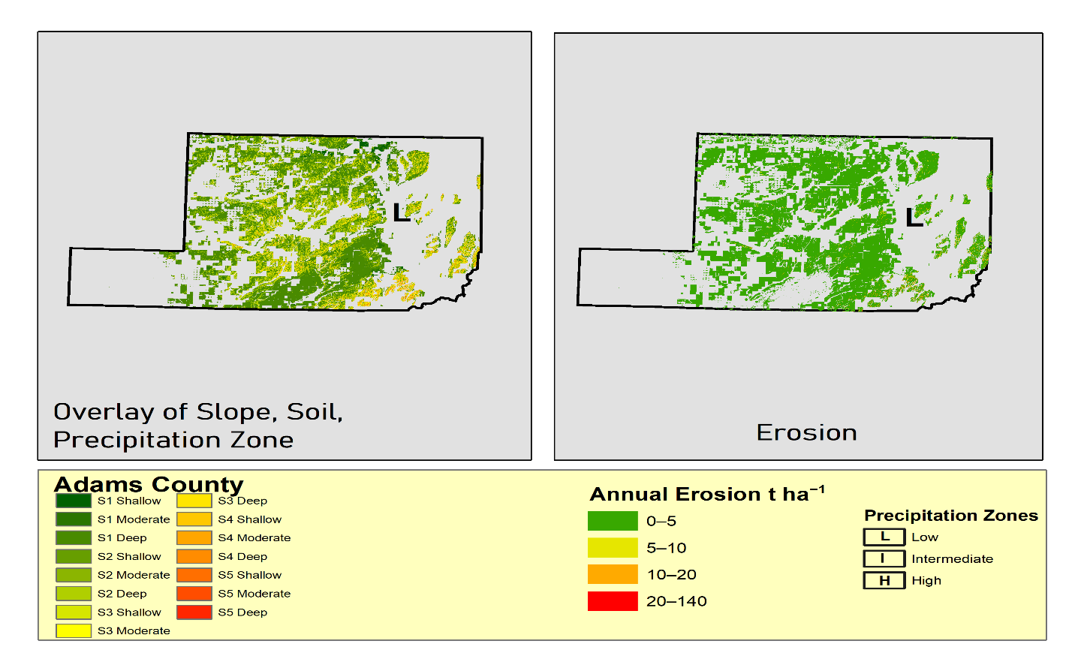
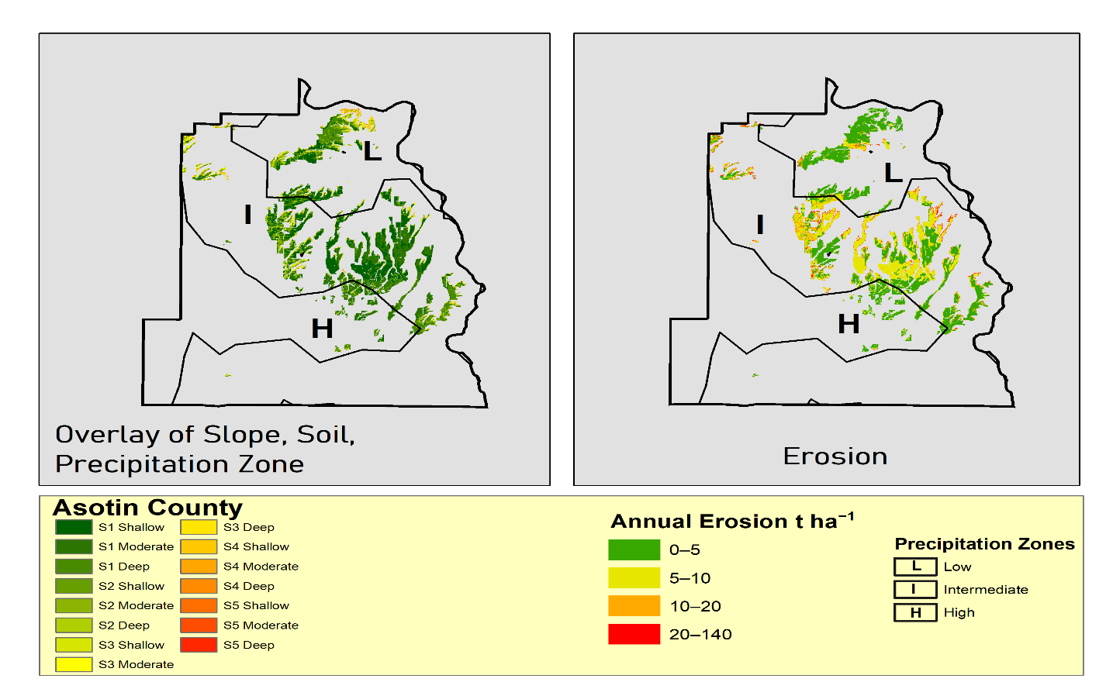
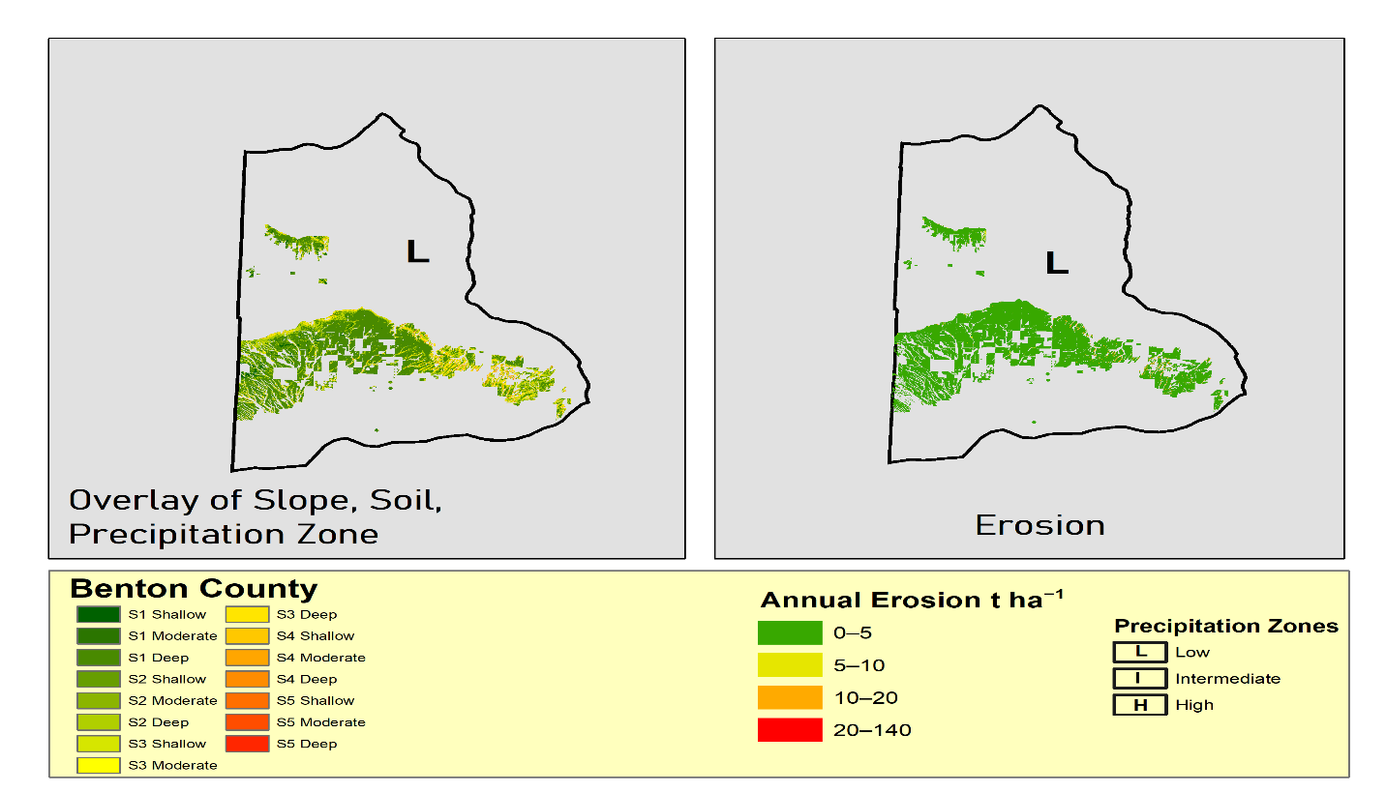

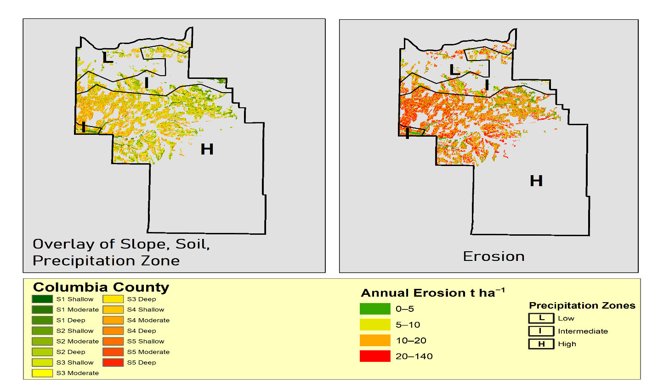

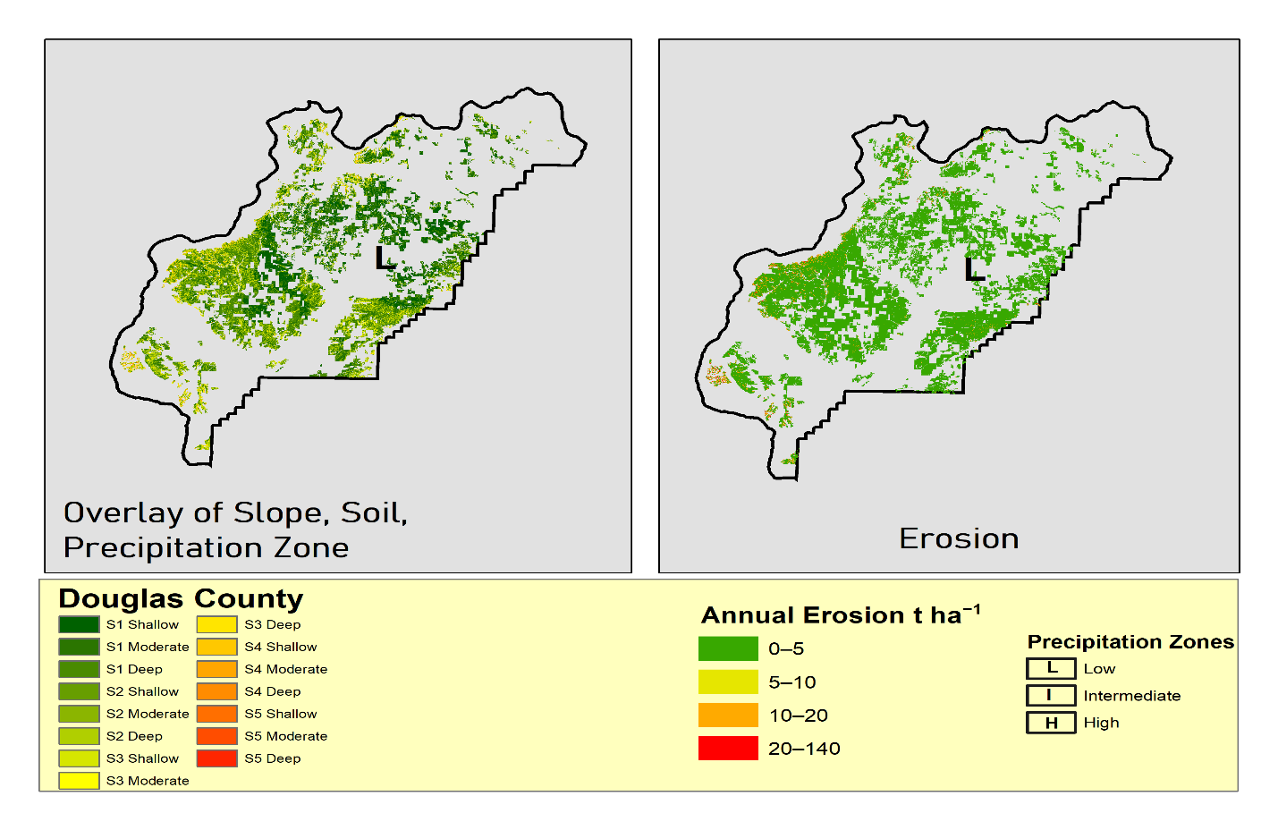
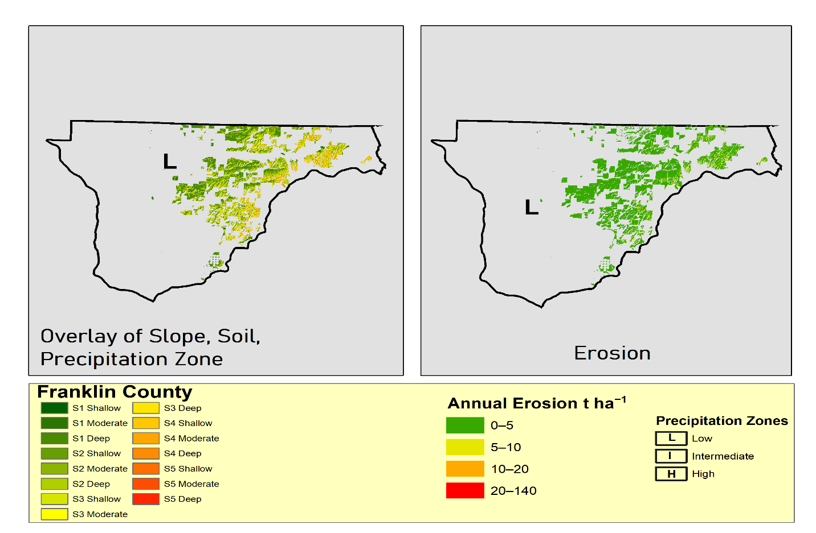

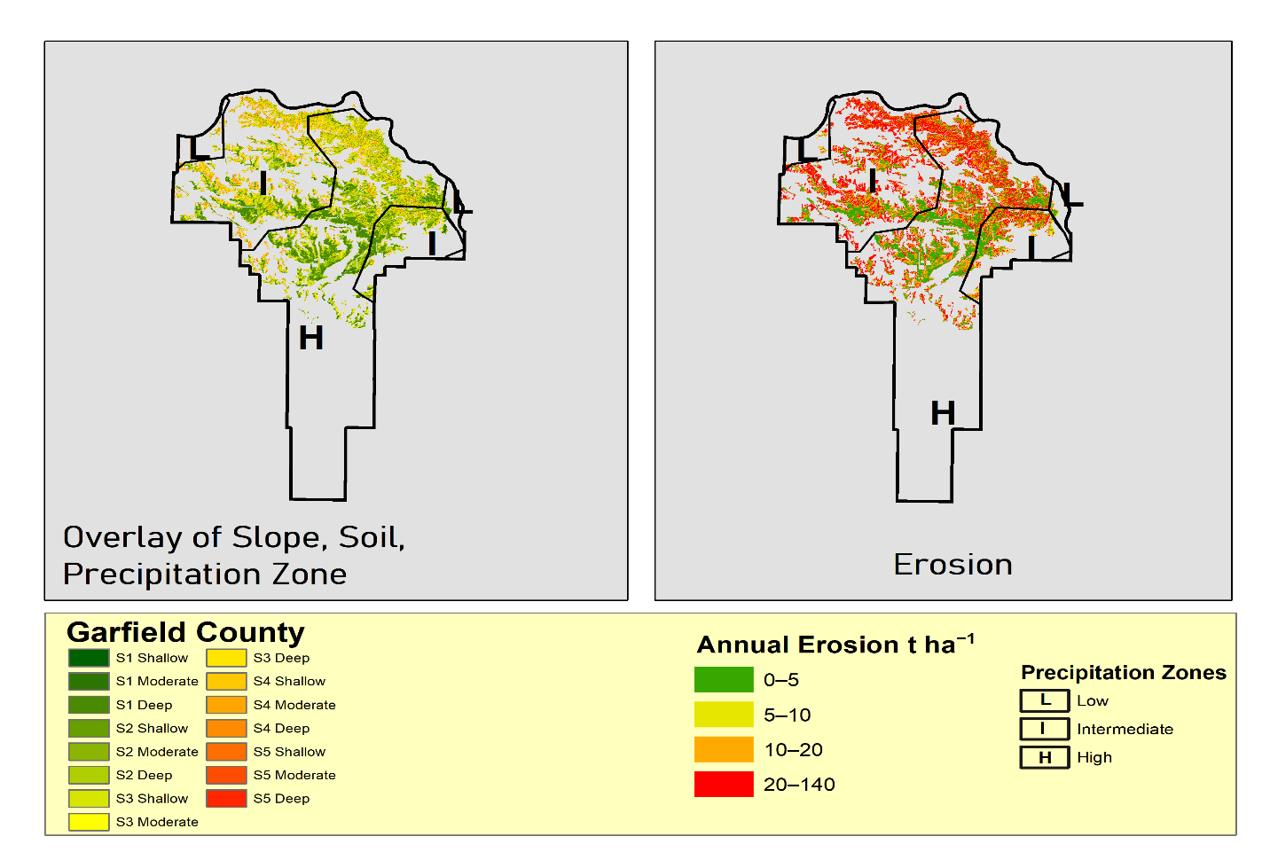

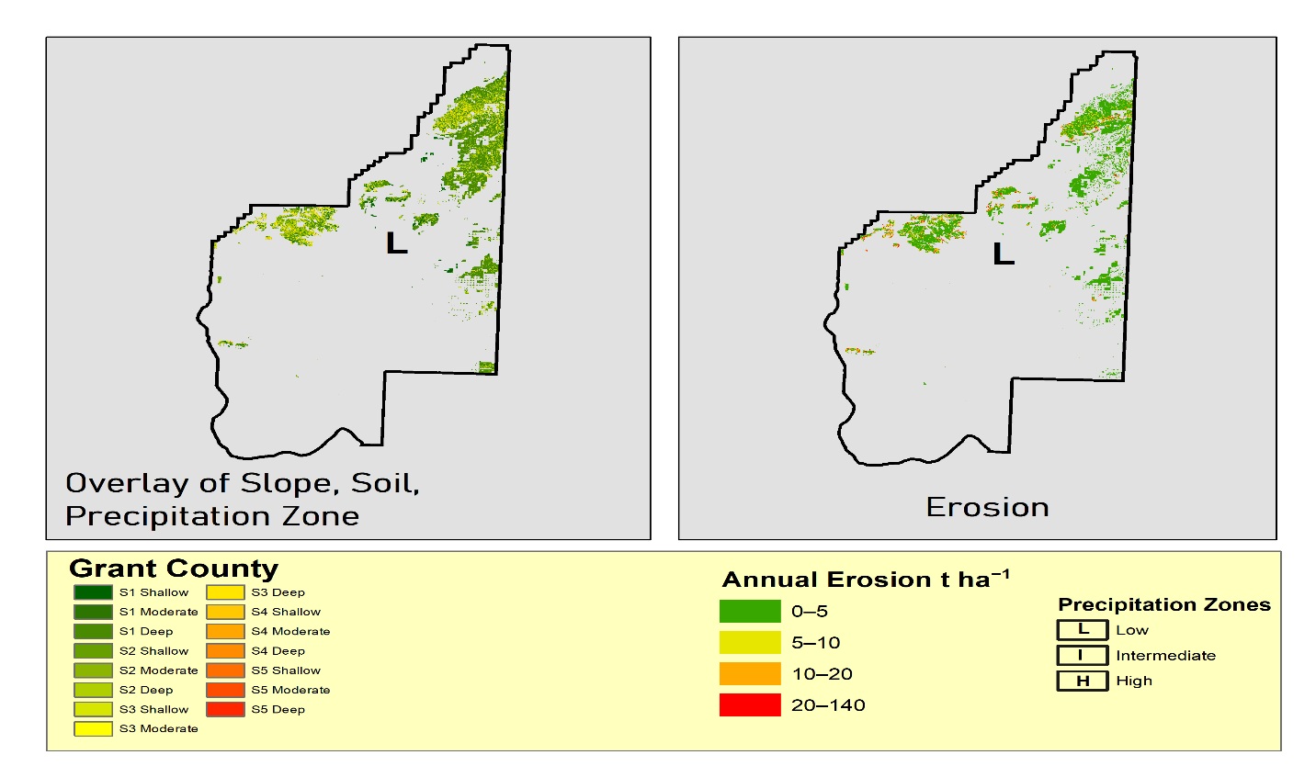

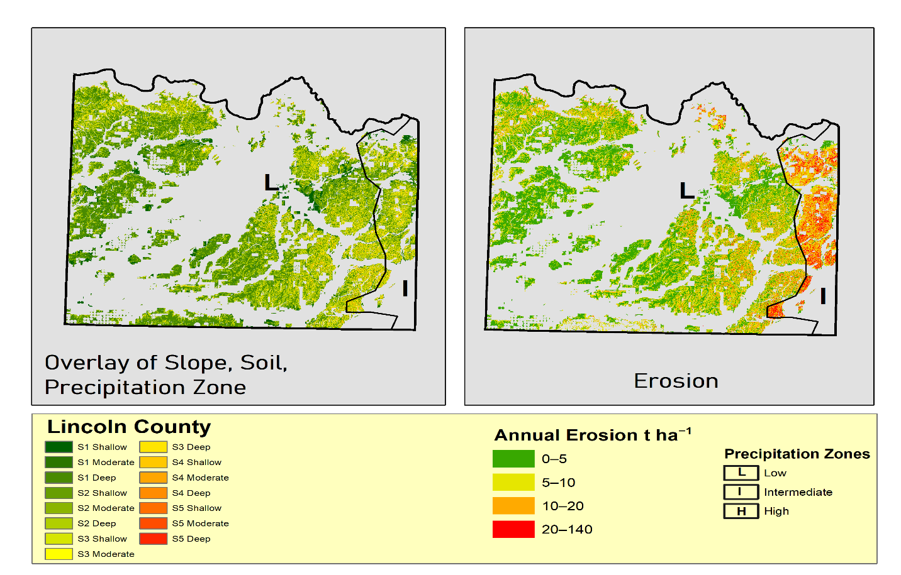

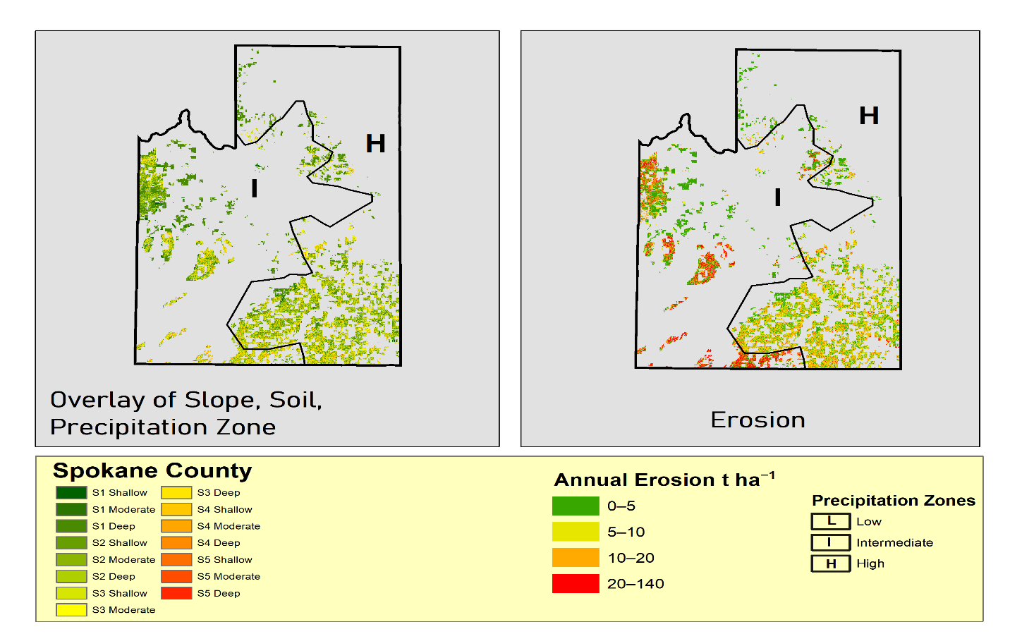
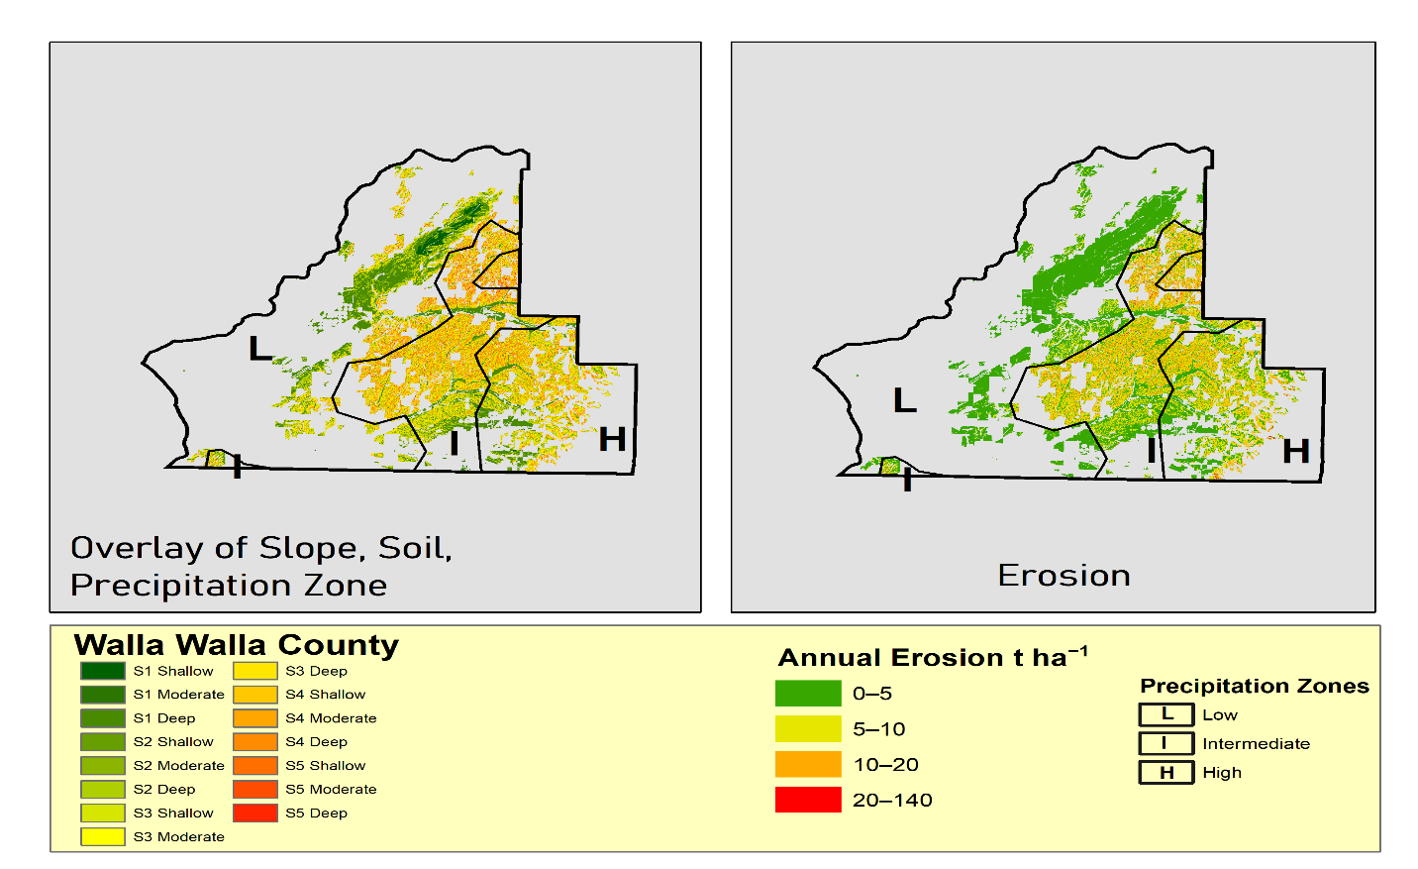

S6. Temporal Variation of Erosion Rates

