Citation: Mitchell, M.E., S.D. Shifflett, T. Newcomer-Johnson, A. Hodaj, W. Crumpton, J. Christensen, B. Dyson, T.J. Canfield, S. Richmond, M. Helmers, D. Lemke, M. Lechtenberg, C. Taylor and K.J. Forshay. 2022. Ecosystem services in Iowa agricultural catchments: Hypotheses for scenarios with water quality wetlands and improved tile drainage. Journal of Soil and Water Conservation 77(4):426-440. https://doi.org/10.2489/jswc.2022.00127.
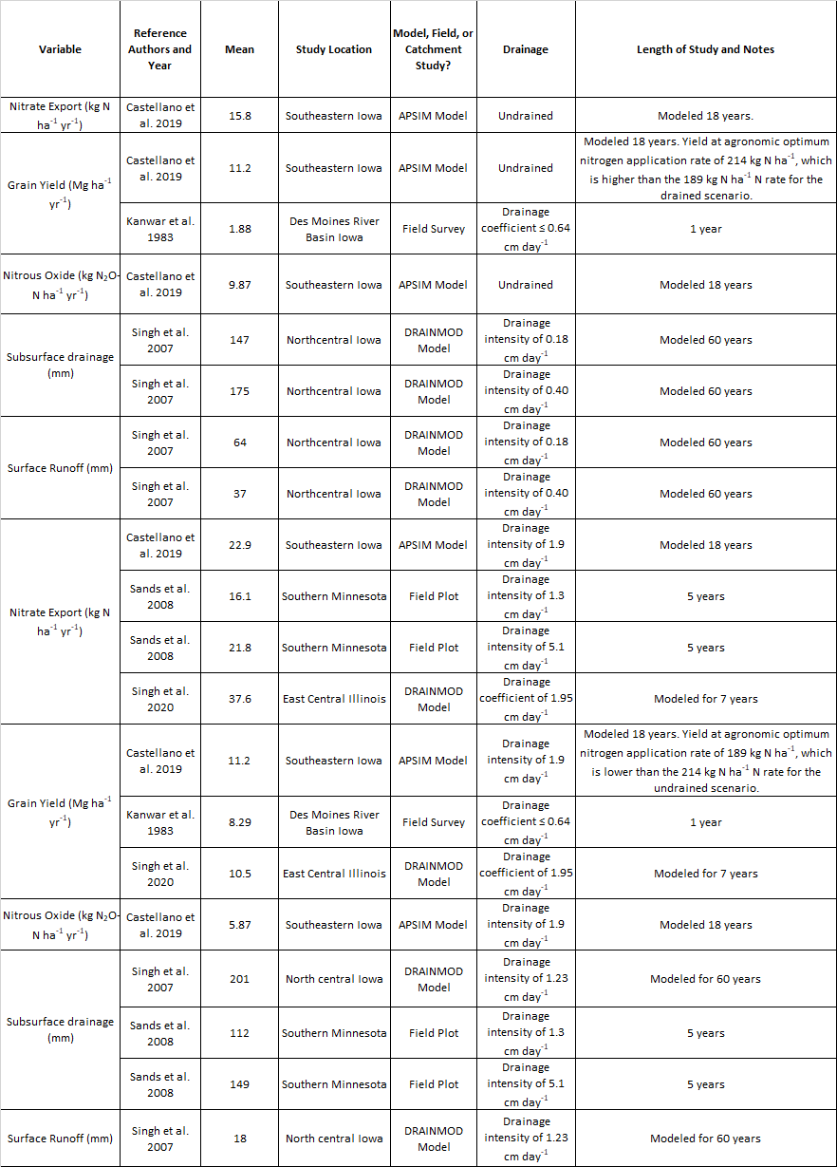
Supplementary Table 1. Literature review results for agricultural systems.
Supplementary Table 2. Literature review results for water quality wetlands. HLR = Hydraulic Loading Rate.
